**Database System**

*Project Title*: **Event Management System**

*Submitted by* ***:***  *Submitted to :*

Tayyaba Abbas BSEF21M011 Sir. Asif Sohail

Laiba Shakoor BSEF21M021

Aalia Siddique BSEF21M034



**University of Punjab**

Faculty of Computing and Information Technology, Allama Iqbal Campus

***Introduction of Event Management System:***

The **Event Management System** (EMS) orchestrates seamless event execution by integrating a **network** of interrelated tables. The core "Event" table serves as a hub, linking to diverse subtypes like exhibitions, conferences, and workshops, each with specific attributes. Organizers, attendees, staff, and resources are efficiently managed through dedicated tables. Marketing strategies, feedback, and budgeting are streamlined, ensuring comprehensive event **coordination**. Attendee information is captured, and venue and ticket details are synchronized. The system's modular design allows for **flexibility** and **adaptability**, making it a robust solution for the **end-to-end management** of various events with precision and ease.

***Entity Relation Diagram of System:***

The following Entity-Relationship Diagram (ERD) represents the relationships of different entities in this **Event Management System** with respect to their attributes and primary as well as foreign keys. It also describes this system’s 1:1, 1:M, M:N relationships.

1. ***ERD Model:***

The entities for **Event Management System** are as follows:

1. Event
2. Workshop
3. Conference
4. Concert
5. Exhibition
6. Sport
7. Organizer
8. Venue
9. Attendee
10. Customer
11. Staff
12. Catering
13. Security
14. Technical crew
15. Décor
16. Resource
17. Budget
18. Ticket
19. Marketing
20. Digital
21. Traditional
22. Feedback
23. ***Attributes of Entities:***

|  |  |
| --- | --- |
| Entities | Attributes |
| Event | eventID, E_type, E_time, E_date, E_status |
| Workshop | eventID, ws_instructor, ws_duration, ws_category |
| Exhibition | eventID, ex_exhibitor, ex_booth, ex_booth_des |
| Conference | eventID, conf_speakerID, conf_speakerName |
| Concert | eventID, con_artistID, con_artist |
| Sport | eventID,teamID, spo_name, spo_result, spo_bestPlayer,spo_refree |
| Organizer | orgID, org_name, org_DOB, org_cnic, org_email, org_phone#, org_address, org_sal |
| Venue | venueID, V_capacity, V_name, V_address |
| Attendee | attendeeID, att_name, att_cnic, att_phone#, att_email |
| Customer | customerID, c_name, c_address, c_email, c_phone#,c_cnic |
| Ticket | ticketID, T_type, T_price, T_availibility |
| Staff | staffID, S_name, S_address, S_email, S_phone#, S_DOB, S_type, S_salary, S_cnic |
| Catering | staffID, cat_category |
| Technical_Crew | staffID, TC_role |
| Security | staffID, sec_weapons1,sec_weapons2 |
| Décor | staffID, D_theme,D_floralArrangements, D_  sittingArrangements ,D_sittingArrangements |
| Resource | resourceID, R_name, R_price, R_qty |
| Budget | budgetID, B_totalAmount, B_amountPaid, B_amountDue, B_estimatedAmount |
| Marketing | marketingID, M_type, M_cost |
| Traditional | marketingID ,TM_material, TM_mediaOutlet,  TM_printProduction |
| Digital | marketingID, DM_socialMedia, DM_email, DM_SEO,  DM_strategy |
| Feedback | feedbackID, fb_rating, fb_comments |

1. ***Connectivity Table:***

|  |  |  |  |
| --- | --- | --- | --- |
| **Entity** | **Relationship** | **Connectivity** | **Entity** |
| Event | Is attended by | M:M | Attendee |

|  |  |  |  |
| --- | --- | --- | --- |
| Staff | Works in | M:M | Event |

|  |  |  |  |
| --- | --- | --- | --- |
| Event | Has used | M:M | Resource |

1. ***ERD Diagram:***

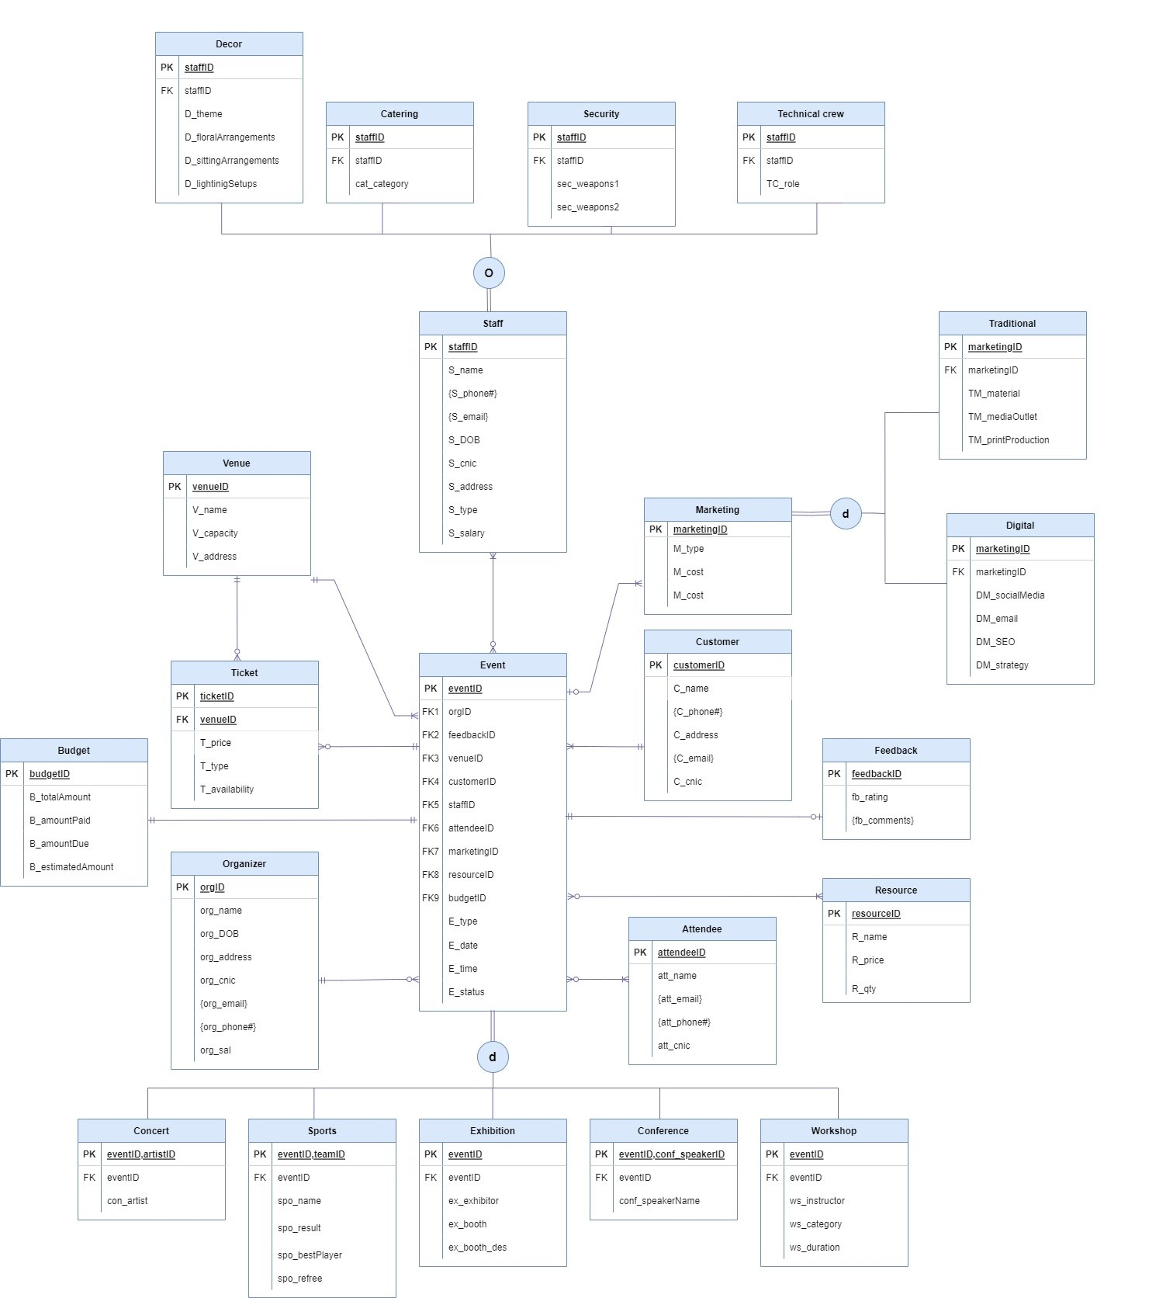

**Relational Schema by using both bottom-up approach**

**and top-down approach**

***Top Down Approach***

**1.Event**(eventID,E_type,E_date,E_time,E_status,orgID,feedbackID,customerID,staffID,attendeeID,ticketID,maketingID,resourceID,budgetID)

* **1NF (remove multivalued artibute)**

This table is already in 1NF because there is no multivalued artibute in event table.

* **2NF(remove partial dependency)**

This table is already in 2NF because there is no partial dependency in event table.All non-key artibutes are fully functional dependent on primary key**(eventID).**

* **3NF(remove transitive dependency)**

The table is already in 3NF because there is no transitive dependency exist in this table.

**The final normalized form is**

**Event**(eventID,E_type,E_date,E_time,E_status,orgID,feedbackID,customerID,staffID, ticketID ,attendeeID,maketingID,resourceID,budgetID)

2.**Organizer(**orgID,org_name,org_DOB,org_address,org_cnic,org_email,org_phone#,org_sal)

* **1NF (remove multivalued artibute)**

There are two multivalued artibutes org_email,org_phone# so we decompose in separate table

**Organizer(**orgID,org_name,org_DOB,org_address,org_cnic, org_sal)

**OrgEmail(**orgID(fk), org_email)

**orgPhone**(orgID(fk),org_phone#)

* **2NF(remove partial dependency)**

These tables are already in 2NF because there is no partial dependency .All non-key artibutes are fully functional dependent on primary keys.

* **3NF(remove transitive dependency)**

These tables are already in 3NF because there is no transitive dependency exist in these tables.

**The final normalized form is:**

**Organizer(**orgID,org_name,org_DOB,org_address,org_cnic, org_sal)

**OrgEmail(**orgID(fk), org_email)

**orgPhone**(orgID(fk),org_phone#)

**3.Venue**(venueID,V_name,V_capacity,V_address)

* **1NF (remove multivalued artibutes)**

This table is already in 1NF because there is no multivalued artibute in this table.

* **2NF(remove partial dependency)**

This table is already in 2NF because there is no partial dependency in this table.All non-key artibutes are fully functional dependent on primary key**(orgID).**

* **3NF(remove transitive dependency)**

The table is already in 3NF because there is no transitive dependency exist in this table.

**The final normalized form is:**

**Venue**(venueID,V_name,V_capacity,V_address)

**4.Ticket**(ticketID, venueID ,T_price,T_type,T_availibility)

* **1NF (remove multivalued artibutes)**

This table is already in 1NF because there is no multivalued artibute in this table.

* **2NF(remove partial dependency)**

This table is already in 2NF because there is no partial dependency in this table.All non-key artibutes are fully functional dependent on primary key**(ticketID).**

* **3NF(remove transitive dependency)**

There is transitive dependency exist in this table as

**T_type->T_price**

Both T_type and T_price are non-prime artibutes

**Ticket**(ticketID,T_type,T_availibility, venueID)

**TicketPrice**(T_type, T_price)

**The final normalized form is:**

**Ticket**(ticketID,T_type,T_availibility, venueID)

**TicketPrice**(T_type, T_price)

**5.Attendee**(attendeeID,Att_name,Att_email,Att_phone#,Att_cnic)

* **1NF (remove multivalued artibute)**

There are two multivalued artibutes Att_email,Att_phone# so we decompose in separate table

**Attendee**(attendeeID,Att_name, Att_cnic)

**Atten_Email**(attendeeID(fk), Att_email)

**Atten_Phone**(attendeeID(fk), Att_phone#)

* **2NF(remove partial dependency)**

These tables are already in 2NF because there is no partial dependency .All non-key artibutes are fully functional dependent on primary keys.

* **3NF(remove transitive dependency)**

These tables are already in 3NF because there is no transitive dependency exist in these tables.

**The final normalized form is:**

**Attendee**(attendeeID,Att_name, Att_cnic)

**Atten_Email**(attendeeID(fk), Att_email)

**Atten_Phone**(attendeeID(fk), Att_phone#)

**6.Customer**(customerID,C_name,C_phone#,C_address,C_email,C_cnic)

* **1NF (remove multivalued artibute)**

There are two multivalued artibutes C_email,C_phone# so we decompose in separate table

**Customer(**customerID,C_name, C_address,C_cnic)

**Cust_Email(**customerID(fk), C_email)

**Cust_Phone(**customer(fk), C_phone#)

* **2NF(remove partial dependency)**

These tables are already in 2NF because there is no partial dependency .All non-key artibutes are fully functional dependent on primary keys.

* **3NF(remove transitive dependency)**

These tables are already in 3NF because there is no transitive dependency exist in these tables.

**The final normalized form is:**

**Customer(**customerID,C_name, C_address,C_cnic)

**Cust_Email(**customerID(fk), C_email)

**Cust_Phone(**customerID(fk), C_phone#)

**7. Staff**(staffID,S_name,S_phone#,S_email,S_DOB,S_address,S_type,S_salary)

* **1NF (remove multivalued artibute)**

There are two multivalued artibutes S_email,S_phone# so we decompose in separate table

**Staff**(staffID,S_name, S_DOB,S_address,S_type,S_salary)

**Staff_Email**(staffID(fk), S_email)

**Staff_Phone**(staffID(fk), ,S_phone#)

* **2NF(remove partial dependency)**

These tables are already in 2NF because there is no partial dependency .All non-key artibutes are fully functional dependent on primary keys.

* **3NF(remove transitive dependency)**

Transitive dependency exist in staff table as

**S_type->S_salary**

The S->type and S_salary both are non-prime artibutes.

**Staff**(staffID,S_name, S_DOB,S_address,S_type)

**Staff_sal(**S_type, S_salary)

**Staff_Email**(staffID(fk), S_email)

**Staff_Phone**(staffID(fk),S_phone#)

**The final normalized form is:**

**Staff**(staffID,S_name, S_DOB,S_address,S_type)

**Staff_sal(**S_type, S_salary)

**Staff_Email**(staffID(fk), S_email)

**Staff_Phone**(staffID(fk), ,S_phone#)

**8.Feedback**(feedbackID,fb_ratings,fb_comments)

* **1NF (remove multivalued artibutes)**

This table exist multivalued artibute e.g fb_comments

**Feedback**(feedbackID,fb_comments)

**Feedback_comm**(feedbackID(fk), fb_comments)

* **2NF(remove partial dependency)**

These tables are already in 2NF because there is no partial dependency .All non-key artibutes are fully functional dependent on primary keys.

* **3NF(remove transitive dependency)**

These tables are already in 3NF because there is no transitive dependency exist in these tables.

**The final normalized form is:**

**Feedback**(feedbackID,fb_ratings)

**Feedback_comm**(feedbackID(fk), fb_comments)

**9.Resources**(resourceID,R_name,R_price,R_qty)

* **1NF (remove multivalued artibutes)**

This table is already in 1NF because there is no multivalued artibute in this table.

* **2NF(remove partial dependency)**

These tables are already in 2NF because there is no partial dependency .All non-key artibutes are fully functional dependent on primary keys.

* **3NF(remove transitive dependency)**

These tables are already in 3NF because there is no transitive dependency exist in these tables.

**Final normalized form is:**

**Resources(**(resourceID,R_name,R_price,R_qty)

10**.Budget**(budgetID,B_totalAmount,B_amountPaid,B_amountDue,B_estimatedAmount)

* **1NF (remove multivalued artibutes)**

This table is already in 1NF because there is no multivalued artibute in this table.

* **2NF(remove partial dependency)**

These tables are already in 2NF because there is no partial dependency .All non-key artibutes are fully functional dependent on primary keys.

* **3NF(remove transitive dependency)**

These tables are already in 3NF because there is no transitive dependency exist in these tables.

**Final normalized form is:**

**Budget**(budgetID,B_totalAmount,B_amountPaid,B_amountDue,B_estimatedAmount)

**11.Marketing**(marketingID,M_type,M_cost)

**This table is aleardy in 1NF,2NF and 3NF**

# ***Bottom Up Approach***

**Relation**(eventID,E_type,E_date,E_time,E_status,orgID,org_name,org_DOB,org_address,org_cnic,org_email,org_phone#,org_sal,feedbackID,fb_ratings,fb_comments,venueID,V_name,V_capacity,V_address,customerID,C_name,C_phone#,C_address,C_email,C_cnic,staffID,S_name,S_phone#,S_email,S_DOB,S_address,S_type,S_salary,attendeeID,Att_name,Att_email,Att_phone#,Att_cnic,maketingID,M_type,M_cost,resourceID,R_name,R_price,budgetID,B_totalAmount,B_amountPaid,B_amountDue,B_estimatedAmount,ticketID,T_price,T_type,T_availibility,qty)

* **1NF(remove multivalued artibutes)**

**Event(**eventID,E_type,E_date,E_time,E_status,orgID,org_name,org_DOB,org_address,org_cnic,org_sal,feedbackID,fb_ratings,venueID,V_name,V_capacity,V_address,customerID,C_name,C_address,C_cnic,staffID,S_name,S_DOB,S_address,S_type,S_salary,attendeeID,Att_name,Att_cnic,marketingID,M_type,M_cost,resourceID,R_name,R_price,budgetID,B_totalAmount,B_amountPaid,B_amountDue,B_estimatedAmount,ticketID,T_price,T_type,T_availibility,qty)

**OrgEmail(**orgID(fk), org_email)

**orgPhone**(orgID(fk),org_phone#)

**Atten_Email**(attendeeID(fk), Att_email)

**Atten_Phone**(attendeeID(fk), Att_phone#)

**Cust_Email(**customerID(fk), C_email)

**Cust_Phone(**customer(fk), C_phone#)

**Staff_Email**(staffID(fk), S_email)

**Staff_Phone**(staffID(fk), ,S_phone#)

**Feedback_comm**(feedbackID(fk), fb_comments)

* **2NF(remove partial dependency)**

All these relations are already in 2NF because there in no partial dependency exitst in these table.

* **3NF(remove transitive dependency)**

**1.Event(**eventID,E_type,E_date,E_time,E_status,orgID,feedbackID,,venueID,customerID,staffID,attendeeID, marketingID,resourceID, ticketID)

**organizer(**orgID,org_name,org_DOB,org_address,org_cnic,org_sal)

**Venue(**venueID**,**V_name,V_capacity,V_address,ticketID,T_price,

T_type,T_availibility)

This table is further normalized in 3NF because there is transitive dependency

**tickeID-> T_price,T_type,T_availibility**

**Ticket**(tickeID,T_price,T_type,T_availibility,venueID)

* There is transitive dependency in this event_ticket table

T_type->T_price

**ticket_price(**T_type,T_price)

**Venue(**venueID**,**V_name,V_capacity,V_address)

**Feedback(**feedbackID,fb_ratings)

**Attendee**(attendeeID,Att_name, Att_cnic)

**Customer(**customerID,C_name, C_address,C_cnic)

**Staff**(staffID,S_name, S_DOB,S_address,S_type,S_salary)

This table is more normalized because there is transitive dependency between

**S_type->S_salary**

**Staff**(staffID,S_name, S_DOB,S_address,S_type)

**Staff_sal(**S_type, S_salary)

**Budget**(budgetID,B_totalAmount,B_amountPaid,B_amountDue,B_estimatedAmount)

**Marketing**(marketingID,M_type,M_cost)

**All other tables other than event are already in 3NF**

**Final normalized form is:**

1. **1.Event(**eventID,E_type,E_date,E_time,E_status,orgID,feedbackID,customerID,staffID,attendeeID, marketingID,resourceID, ticketID)
2. **Organizer(**orgID,org_name,org_DOB,org_address,org_cnic,org_sal)
3. **Ticket**(tickeID,T_price,T_type,T_availibility,venueID)
4. **ticket_price(**T_type,T_price)
5. **Venue(**venueID**,**V_name,V_capacity,V_address)
6. **Feedback(**feedbackID,fb_ratings)
7. **Attendee**(attendeeID,Att_name, Att_cnic)
8. **Customer(**customerID,C_name, C_address,C_cnic)
9. **Staff**(staffID,S_name, S_DOB,S_address,S_type)
10. **Staff_sal(**S_type, S_salary)
11. **Budget**(budgetID,B_totalAmount,B_amountPaid,B_amountDue,B_estimatedAmount)
12. **Marketing**(marketingID,M_type,M_cost)
13. **OrgEmail(**orgID(fk), org_email)
14. **orgPhone**(orgID(fk),org_phone#)
15. **Atten_Email**(attendeeID(fk), Att_email)
16. **Atten_Phone**(attendeeID(fk), Att_phone#)
17. **Cust_Email(**customerID(fk), C_email)
18. **Cust_Phone(**customer(fk), C_phone#)
19. **Staff_Email**(staffID(fk), S_email)
20. **Staff_Phone**(staffID(fk), ,S_phone#)
21. **Resources**(resourceID,R_name,R_price,qty)
22. **Feedback_comm**(feedbackID(fk), fb_comments)

***Description of relations***

1. ***Table Name: Event***

|  |  |  |  |
| --- | --- | --- | --- |
| Attributes | Data Type | Size | Constraints |
| eventID | Number | 4 | Primary Key |
| E_type | Varchar2 | 15 | Can be ‘CONCERT’, ‘WORKSHOP’, ‘CONFERENCE’, ‘EXHIBITION’,‘SPORT’ |
| E_date | Date |  |  |
| E_time | Varchar2 | 8 |  |
| E_status | Varchar2 | 10 | Can be ‘COMPLETED’, ‘PENDING’ |
| budgetID | Number | 4 | Foreign Key |
| orgID | Number | 4 | Foreign Key |
| venueID | Number | 4 | Foreign Key |
| StaffID | Number | 4 | Foreign Key |
| FeedbackID | Number | 4 | Foreign Key |
| CustomerID | Number | 4 | Foreign Key |
| AttendeeID | Number | 4 | Foreign Key |
| MarketingID | Number | 4 | Foreign Key |
| ResourceID | Number | 4 | Foreign Key |

1. ***Table Name: Exhibition***

|  |  |  |  |
| --- | --- | --- | --- |
| Attributes | Data Type | Size | Constraints |
| eventID | Number | 4 | Primary Key, Foreign Key |
| ex_exhibitor | Varchar2 | 15 | Not null |
| ex_booth | Number | 5 |  |
| ex_booth_des | Varchar2 | 25 |  |

1. ***Table Name: Conference***

|  |  |  |  |
| --- | --- | --- | --- |
| Attributes | Data Type | Size | Constraints |
| eventID | Number | 4 | Primary Key, Foreign Key |
| conf_speakerID | Number | 4 | Primary Key |
| conf_speakerName | Varchar2 | 25 |  |

1. ***Table Name: Workshop***

|  |  |  |  |
| --- | --- | --- | --- |
| Attributes | Data Type | Size | Constraints |
| eventID | Number | 4 | Primary Key, Foreign Key |
| ws_duration | Varchar2 | 10 |  |
| ws_instructor | Varchar2 | 25 | Not null |
| ws_category | Varchar2 | 25 | Can be ‘EDUCATIONAL’, ‘SKILL BUILDING','TRAINING','INTREPRENEURSHIP','HEALTH' |

1. ***Table Name: Concert***

|  |  |  |  |
| --- | --- | --- | --- |
| Attributes | Data Type | Size | Constraints |
| eventID | Number | 4 | Primary Key, Foreign Key |
| artistID | Number | 4 | Primary Key |
| Con_artist | Varchar2 | 25 | Not null |

1. ***Table Name: Sport***

|  |  |  |  |
| --- | --- | --- | --- |
| Attributes | Data Type | Size | Constraints |
| eventID | Number | 4 | Primary Key, Foreign Key |
| teamID | Number | 4 | Primary Key |
| spo_name | Varchar2 | 25 | Not null |
| spo_result | Varchar2 | 10 | Can be ‘WON','LOST','WITHDRAW' |
| spo_bestPlayer | Varchar2 | 25 |  |
| spo_refree | Varchar2 | 25 |  |

1. ***Table Name: Organizer***

|  |  |  |  |
| --- | --- | --- | --- |
| Attributes | Data Type | Size | Constraints |
| orgID | Number | 4 | Primary Key |
| org_name | Varchar2 | 25 | Not null |
| org_DOB | Date |  |  |
| org_cnic | Varchar2 | 15 |  |
| org_address | Varchar2 | 50 |  |
| org_sal | Number | 8 |  |

1. ***Table Name: Org_Email***

|  |  |  |  |
| --- | --- | --- | --- |
| Attributes | Data Type | Size | Constraints |
| orgID | Number | 4 | Primary Key, Foreign Key |
| org_Email | Varchar2 | 20 | Primary Key |

1. ***Table Name: Org_Phone***

|  |  |  |  |
| --- | --- | --- | --- |
| Attributes | Data Type | Size | Constraints |
| orgID | Number | 4 | Primary Key, Foreign Key |
| org_Phone# | Varchar2 | 20 | Primary Key |

1. ***Table Name: Resource***

|  |  |  |  |
| --- | --- | --- | --- |
| Attributes | Data Type | Size | Constraints |
| resourceID | Number | 4 | Primary Key |
| R_name | Varchar2 | 25 | Not null |
| R_price | Number | 10 | Not null |

1. ***Table Name: Venue***

|  |  |  |  |
| --- | --- | --- | --- |
| Attributes | Data Type | Size | Constraints |
| venueID | Number | 4 | Primary Key |
| V_name | Varchar2 | 25 | Not null |
| V_capacity | Number | 4 |  |
| V_address | Varchar2 | 50 |  |

1. ***Table Name: Staff***

|  |  |  |  |
| --- | --- | --- | --- |
| Attributes | Data Type | Size | Constraints |
| staffID | Number | 4 | Primary Key |
| S_name | Varchar2 | 25 | Not Null |
| S_DOB | Date |  |  |
| S_cnic | Varchar2 | 15 |  |
| S_adddress | Varchar2 | 50 |  |
| S_type | Char | 1 | Can be ‘C’,’D’,’S’,’T’ and Foreign Key |

1. ***Table Name: Staff_sal***

|  |  |  |  |
| --- | --- | --- | --- |
| Attributes | Data Type | Size | Constraints |
| S_type | Char | 1 | Can be ‘C’,’D’,’S’,’T’ and Primary Key |
| S_salary | Number | 8 | Not Null |

1. ***Table Name: Staff_Phone***

|  |  |  |  |
| --- | --- | --- | --- |
| Attributes | Data Type | Size | Constraints |
| staffID | Number | 4 | Primary Key and Foreign Key |
| S_phone# | Varchar2 | 12 | Primary Key |

1. ***Table Name: Staff_Email***

|  |  |  |  |
| --- | --- | --- | --- |
| Attributes | Data Type | Size | Constraints |
| staffID | Number | 4 | Primary Key and Foreign Key |
| S_email | Varchar2 | 20 | Primary Key |

1. ***Table Name: Security***

|  |  |  |  |
| --- | --- | --- | --- |
| Attributes | Data Type | Size | Constraints |
| staffID | Number | 4 | Primary Key and Foreign Key |
| sec_weapons1 | Varchar2 | 15 |  |
| sec_weapons2 | Varchar2 | 15 |  |

1. ***Table Name: Catering***

|  |  |  |  |
| --- | --- | --- | --- |
| Attributes | Data Type | Size | Constraints |
| staffID | Number | 4 | Primary Key and Foreign Key |
| Cat_category | Varchar2 | 15 | Can be ‘BUFFET’,’CORPORATE’,’DESERT’,’BREAKFAST’ |

1. ***Table Name: Technical_crew***

|  |  |  |  |
| --- | --- | --- | --- |
| Attributes | Data Type | Size | Constraints |
| staffID | Number | 4 | Primary Key and Foreign Key |
| TC_role | Varchar2 | 20 | Can be 'CINEMATOGRAPHER','GAFFE','LIGHTINING',  'PROJECTIONIST','RIGGERS |

1. ***Table Name: Decor***

|  |  |  |  |
| --- | --- | --- | --- |
| Attributes | Data Type | Size | Constraints |
| staffID | Number | 4 | Primary Key and Foreign Key |
| D_theme | Varchar2 | 20 | Can be 'NEON','BLACK AND WIGHT','VINTAGE |
| D_floralArrangements | Varchar2 | 20 | Can be 'BOUQUETS','GARLAND',  'CENTERPIECES |
| D_sittingArrangements | Varchar2 | 20 | Can be 'OPEN','FORMAL','CIRCULAR' |
| D_lightiningSetups | Varchar2 | 20 | Can be 'NATURAL','PHOTOGRAPHY','THREE POINTS' |

1. ***Table Name: Feedback***

|  |  |  |  |
| --- | --- | --- | --- |
| Attributes | Data Type | Size | Constraints |
| feedbackID | Number | 4 | Primary Key |
| fb_rating | Number | 1 |  |

1. ***Table Name: Feedback_comm***

|  |  |  |  |
| --- | --- | --- | --- |
| Attributes | Data Type | Size | Constraints |
| feedbackID | Number | 4 | Primary Key and Foreign Key |
| Fb_comments | Varchar2 | 20 | Primary Key |

1. ***Table Name: Budget***

|  |  |  |  |
| --- | --- | --- | --- |
| Attributes | Data Type | Size | Constraints |
| budgetID | Number | 4 | Primary Key |
| B_totalAmount | Number(10,2) | 25 |  |
| B_amountPaid | Number(10,2) |  |  |
| B_amountDue | Number(10,2) | 15 |  |
| B_estimatedAmount | Number(10,2) | 50 |  |

1. ***Table Name: Marketing***

|  |  |  |  |
| --- | --- | --- | --- |
| Attributes | Data Type | Size | Constraints |
| marketingID | Number | 4 | Primary Key |
| M_type | Char | 1 | Can be ‘D’, ’T’ |
| M_cost | Number | 8 | Not Null |

1. ***Table Name:Traditional***

|  |  |  |  |
| --- | --- | --- | --- |
| Attributes | Data Type | Size | Constraints |
| marketingID | Number | 4 | Primary Key,Foreign Key |
| TM_material | Varchar2 | 40 | Can be 'BROCHURES', 'FLYERS','BUSINESS CARDS' |
| TM_mediaOutlet | Varchar2 | 10 | Can be 'RADIO', 'NEWSPAPER','MAGZINE','TV' |
| TM_printProduction | Varchar2 | 40 | Can be 'RADIO', 'NEWSPAPER','MAGZINE','ARTICLE’ |

1. ***Table Name:Digital***

|  |  |  |  |
| --- | --- | --- | --- |
| Attributes | Data Type | Size | Constraints |
| marketingID | Number | 4 | Primary Key,Foreign Key |
| DM_socialMedia | Varchar2 | 40 | Can be ‘INSTRAGRAM’,’FACEBOOK’,’TWITTER’,  ‘TIKTOK’,,'LINKEDIN','YOUTUBE','SNAPCHAT',  'TUMBLR' |
| DM_email | Varchar2 | 20 | Not Null |
| DM_SEO | Varchar2 | 25 | Can be 'TECHNICAL SEO','UX','OFF PAGE','ON PAGE','KEYWORD RESEARCH' |
| DM_strategy | Varchar2 | 30 | CONTENT CREATION', 'SEO INTEGRATION', 'SOCIAL MEDIA MARKETING', 'EMAIL MARKETING', 'STORYTELLING' |

1. ***Table Name: Attendee***

|  |  |  |  |
| --- | --- | --- | --- |
| Attributes | Data Type | Size | Constraints |
| attendeeID | Number | 4 | Primary Key |
| att_name | Varchar2 | 25 | Not Null |
| att_cnic | Varchar2 | 15 |  |

1. ***Table Name: Atten_Email***

|  |  |  |  |
| --- | --- | --- | --- |
| Attributes | Data Type | Size | Constraints |
| attendeeID | Number | 4 | Primary Key,Foreign key |
| att_email | Varchar2 | 20 | Primary key |

1. ***Table Name: Atten_Phone***

|  |  |  |  |
| --- | --- | --- | --- |
| Attributes | Data Type | Size | Constraints |
| attendeeID | Number | 4 | Primary Key,Foreign key |
| att_phone# | Varchar2 | 12 | Primary key |

1. ***Table Name: Customer***

|  |  |  |  |
| --- | --- | --- | --- |
| Attributes | Data Type | Size | Constraints |
| customerID | Number | 4 | Primary Key |
| C_name | Varchar2 | 25 | Not Null |
| C_addres | Varchar2 | 50 |  |
| C_cnic | Varchar2 | 15 |  |

1. ***Table Name: Cust_Email***

|  |  |  |  |
| --- | --- | --- | --- |
| Attributes | Data Type | Size | Constraints |
| customerID | Number | 4 | Primary Key,Foreign key |
| C_email | Varchar2 | 20 | Primary key |

1. ***Table Name: Atten_Phone***

|  |  |  |  |
| --- | --- | --- | --- |
| Attributes | Data Type | Size | Constraints |
| customerID | Number | 4 | Primary Key,Foreign key |
| C_phone# | Varchar2 | 12 | Primary key |

1. ***Table Name: Ticket***

|  |  |  |  |
| --- | --- | --- | --- |
| Attributes | Data Type | Size | Constraints |
| ticketID | Number | 4 | Primary Key |
| venueID | Number | 4 | Foreign Key |
| T_type | Varchar2 | 25 | Can be 'VIP','REGULAR',Foreign key |
| T_availability | Char | 1 | Can be 'Y','N' |
| C_cnic | Varchar2 | 15 |  |

1. ***Table Name: TicketPrice***

|  |  |  |  |
| --- | --- | --- | --- |
| Attributes | Data Type | Size | Constraints |
| T_type | Varchar2 | 25 | Can be 'VIP','REGULAR',Primary key |
| T_PRICE | Number | 4 |  |

***Table Creation***

1. ***Event table:***

create table Event

(

eventID NUMBER(4) CONSTRAINT eventID_PK PRIMARY KEY,

E_type VARCHAR2(15) CONSTRAINT ETYPE_CHK CHECK(E_type IN ('CONCERT','CONFERENCE', 'WORKSHOP', 'EXHIBITION', 'SPORT')),

E_date DATE,

E_time VARCHAR2(8),

E_status VARCHAR2(10) CONSTRAINT ESTATUS_CHK CHECK(E_status IN ('COMPLETED', 'PENDING')),

budgetID NUMBER(4),

orgID NUMBER(4) ,

staffID NUMBER(4),

venueID NUMBER(4),

feedbackID NUMBER(4),

customerID NUMBER(4),

attendeeID NUMBER(4),

marketingID NUMBER(4),

resourceID NUMBER(4),

CONSTRAINT EVENT_ORGID_FK FOREIGN KEY(orgID) REFERENCES Organizer(orgID),

CONSTRAINT EVENT_FEEDBACKID_FK FOREIGN KEY(feedbackID) REFERENCES Feedback(feedbackID),

CONSTRAINT EVENT_VENUEID_FK FOREIGN KEY(venueID) REFERENCES Venue(venueID),

CONSTRAINT EVENT_CUSTOMERID_FK FOREIGN KEY(customerID) REFERENCES Customer(customerID),

CONSTRAINT EVENT_STAFF_FK FOREIGN KEY(staffID) REFERENCES Staff(staffID),

CONSTRAINT EVENT_ATTENDEE_FK FOREIGN KEY(attendeeID) REFERENCES Attendee(attendeeID),

CONSTRAINT EVENT_MARKETING_FK FOREIGN KEY(marketingID) REFERENCES Marketing(marketingID),

CONSTRAINT EVENT_BUDGET_FK FOREIGN KEY(budgetID) REFERENCES Budget(budgetID),

CONSTRAINT EVENT_RES_FK FOREIGN KEY (resourceID) REFERENCES Res(resourceID) );

**Event Subtypes:**

1. ***Exhibition Event:***

CREATE TABLE Exhibition

(

eventID NUMBER(4),

ex_exhibitor VARCHAR2(15) CONSTRAINT EXHIBITION_NN NOT NULL,

ex_booth NUMBER(5),

ex_booth_des VARCHAR2(25),

CONSTRAINT EXHIBITION_FK FOREIGN KEY(eventID) REFERENCES Event(eventID),

CONSTRAINT EXHIBITION_PK PRIMARY KEY(eventID)

);

1. ***Conference Event:***

CREATE TABLE Conference

(

eventID NUMBER(4),

conf_speakerID NUMBER(4),

conf_speakerName VARCHAR2(25),

CONSTRAINT CONFERENCE_PK PRIMARY KEY (eventID, conf_speakerID ),

CONSTRAINT CONFERENCE_FK FOREIGN KEY (eventID) REFERENCES Event(eventID)

);

1. ***Workshop Event:***

CREATE TABLE Workshop

(

eventID NUMBER(4),

ws_instructor VARCHAR2(25) CONSTRAINT WORKSHOP_NN NOT NULL,

ws_duration VARCHAR2(10),

ws_category VARCHAR2(25) CONSTRAINT WORKSHOP_CATEGORY_CHK CHECK(ws_category IN ('EDUCATIONAL','SKILL BUILDING','TRAINING','INTREPRENEURSHIP','HEALTH')),

CONSTRAINT WORKSHOP_PK PRIMARY KEY (eventID),

CONSTRAINT WORKSHOP_FK FOREIGN KEY (eventID) REFERENCES Event(eventID)

);

1. ***Concert Event:***

CREATE TABLE Concert

(

eventID NUMBER(4),

artistID NUMBER(4),

con_artist VARCHAR2(25) CONSTRAINT CONCERT_ARTIST_NN NOT NULL,

CONSTRAINT CONCERT_PK PRIMARY KEY (eventID, artistID),

CONSTRAINT CONCERT_FK FOREIGN KEY (eventID) REFERENCES Event(eventID)

);

1. ***Sports Event:***

CREATE TABLE Sport

(

eventID NUMBER(4),

teamID NUMBER(4),

spo_name VARCHAR2(25) CONSTRAINT SPORT_NAME_NN NOT NULL,

spo_result VARCHAR2(10) CONSTRAINT SPORT_RESULT_CHK CHECK(spo_result IN('WON','LOST','WITHDRAW')),

spo_bestPlayer VARCHAR2(25),

spo_refree VARCHAR2(25),

CONSTRAINT SPORT_FK FOREIGN KEY(eventID) REFERENCES Event(eventID),

CONSTRAINT SPORT_PK PRIMARY KEY(eventID,teamID)

);

1. ***Organizer table:***

CREATE TABLE Organizer

(

orgID NUMBER(4) CONSTRAINT ORGID_PK PRIMARY KEY,

org_name VARCHAR(25) CONSTRAINT ORGNAME_NN NOT NULL,

org_DOB DATE,

org_cnic VARCHAR2(15),

org_address VARCHAR2(50) ,

org_salary NUMBER(8)

)

1. ***Org_Email table:***

create table Org_Email

(

orgID number(4),

org_email varchar2(20),

CONSTRAINT ORGANIZER_ID_Email_PK PRIMARY KEY(orgID, org_email),

CONSTRAINT ORGANIZER_FK FOREIGN KEY(orgID) REFERENCES Organizer(orgID) )

1. ***Org_Phone table:***

create table Org_Phone

(

orgID number(4),

org_phone# varchar2(20),

CONSTRAINT ORGANIZER_ID_PHONE_PK PRIMARY KEY(orgID, org_phone#),

CONSTRAINT ORGANIZER_PH_FK FOREIGN KEY(orgID) REFERENCES Organizer(orgID)

)

1. ***Resource table:***

CREATE TABLE Res

(

resourceID NUMBER(4) CONSTRAINT RESOURCE_ID_PK PRIMARY KEY,

R_name VARCHAR2(25) CONSTRAINT R_NAME_NN NOT NULL,

R_price NUMBER(10) CONSTRAINT R_PRICE_NN NOT NULL,

R_qty NUMBER(3)

)

1. ***Marketing table:***

create table Marketing

(

marketingID NUMBER(4) CONSTRAINT MARK_ID_PK PRIMARY KEY,

M_type CHAR(1) CONSTRAINT M_TYPE_CHK CHECK(M_type in('D','T')),

M_cost number(8) CONSTRAINT M_COST_NN NOT NULL

)

**Marketing Subtypes:**

1. ***Traditional Marketing****:*

create table Traditional

(

marketingID NUMBER(4) CONSTRAINT TRAD_MARK_ID_PK PRIMARY KEY,

TM_material VARCHAR2(40) CONSTRAINT TRAD_MATERIAL_CHK CHECK(TM_material IN('BROCHURES', 'FLYERS','BUSINESS CARDS')),

TM_mediaOutlet VARCHAR2(10) CONSTRAINT TRAD_MEDIA_CHK CHECK(TM_mediaOutlet IN('RADIO', 'NEWSPAPER','MAGZINE','TV')),

TM_printProduction varchar2(40) CONSTRAINT TRAD_MARK_PROD_CHK CHECK(TM_printProduction IN ('NEWSPAPER','MAGZINE','ARTICLE')),

CONSTRAINT TRADITIONAL_FK FOREIGN KEY(marketingID) references Marketing(marketingID)

)

1. ***Digital Marketing:***

create table Digital

(

marketingID NUMBER(4) CONSTRAINT DIG_MARK_ID_PK PRIMARY KEY,

DM_socialMedia varchar2(40) CONSTRAINT DIG_SOCIAL_CHK CHECK(DM_socialMedia IN('INSTAGRAM','FACEBOOK','TWITTER','TIKTOK','LINKEDIN','YOUTUBE','SNAPCHAT','TUMBLR')),

DM_email varchar2(20) CONSTRAINT DIG_EMAIL_NN NOT NULL,

DM_SEO varchar2(25) CONSTRAINT DIG_SEO_CHK CHECK(DM_SEO IN('TECHNICAL SEO','UX','OFF PAGE','ON PAGE','KEYWORD RESEARCH')),

DM_strategy varchar2(30) CONSTRAINT DIG_STRATEGY_CHK CHECK(DM_strategy IN ('CONTENT CREATION', 'SEO INTEGRATION', 'SOCIAL MEDIA MARKETING', 'EMAIL MARKETING', 'STORYTELLING')),

CONSTRAINT DIG_FK FOREIGN KEY(marketingID) references Marketing(marketingID)

)

1. ***Feedback table:***

CREATE TABLE Feedback

(

feedbackID NUMBER(4) CONSTRAINT FEEDBACKID_PK PRIMARY KEY,

fb_rating NUMBER(1)

)

1. ***Feedback_comm table:***

create table Feedback_comm

(

feedbackID NUMBER(4) ,

fb_comments VARCHAR2(50),

CONSTRAINT FEEDBACK_ID_COMM_PK PRIMARY KEY(feedbackID , fb_comments),

CONSTRAINT FEEDBACK_COMM_FK FOREIGN KEY(feedbackID) REFERENCES Feedback(feedbackID) )

1. ***Staff table:***

CREATE TABLE Staff

(

staffID NUMBER(4) CONSTRAINT staffID_PK PRIMARY KEY,

S_name VARCHAR(25) CONSTRAINT SNAME_NN NOT NULL,

S_DOB DATE,

S_cnic VARCHAR2(15),

S_address VARCHAR2(50),

S_type CHAR(1) CONSTRAINT STYPE#_CHK CHECK(S_type IN ('C','D','S','T')),

CONSTRAINT Staff_FK FOREIGN KEY(S_type) REFERENCES Staff_sal(S_type)

)

1. ***Staff_Phone table:***

create table Staff_Phone

(

staffID number(4),

S_phone# varchar2(12),

CONSTRAINT STAFF_ID_phone_PK PRIMARY KEY(staffID , S_phone#),

CONSTRAINT STAFF_PH_FK FOREIGN KEY(staffID) REFERENCES Staff(staffID)

)

1. ***Staff_Email table:***

create table Staff_Email

(

staffID number(4),

S_email varchar2(20),

CONSTRAINT STAFF_ID_EMAIL_PK PRIMARY KEY(staffID , S_email),

CONSTRAINT STAFF_EM_FK FOREIGN KEY(staffID) REFERENCES Staff(staffID)

)

1. ***Staff_sal table***

create table Staff_sal

(

S_type CHAR(1) CONSTRAINT STAFF_SAL_CHK CHECK(S_type IN ('C','D','S','T')),

S_salary NUMBER(8) CONSTRAINT STAFF_SAL_NN NOT NULL ,

CONSTRAINT STAFF_SAL_PK PRIMARY KEY(S_type)

)

**Staff Subtypes:**

1. ***Décor staff:***

create table Decor

(

staffID NUMBER(4) CONSTRAINT DECOR_PK PRIMARY KEY,

D_theme VARCHAR(20) CONSTRAINT D_THEME_CHK CHECK(D_theme IN('NEON','BLACK AND WIGHT','VINTAGE')),

D_floralArrangements VARCHAR2(20) CONSTRAINT D_FLORAL_ARR_CHK CHECK(D_floralArrangements IN('BOUQUETS','GARLAND','CENTERPIECES')),

D_sittingArrangements VARCHAR2(20) CONSTRAINT D_SIT_ARR_CHK CHECK(D_sittingArrangements IN('OPEN','FORMAL','CIRCULAR')),

D_lightinigSetups VARCHAR2(20) CONSTRAINT D_LIGHT_SETUP_CHK CHECK(D_lightinigSetups IN('NATURAL','PHOTOGRAPHY','THREE POINTS')),

CONSTRAINT DECOR_FK FOREIGN KEY(staffID) REFERENCES Staff(staffID)

);

1. ***Catering staff:***

create table Catering

(

staffID NUMBER(4) CONSTRAINT CATERING_PK PRIMARY KEY,

cat_category VARCHAR(15) CONSTRAINT CAT_CATEGORY_CHK CHECK(cat_category IN('BUFFET','CORPORATE','DESERT','BREAKFAST')),

CONSTRAINT CAT_FK FOREIGN KEY(staffID) REFERENCES Staff(staffID)

);

1. ***Security staff:***

create table Security

(

staffID NUMBER(4) CONSTRAINT SECURITY_PK PRIMARY KEY,

sec_weapons1 VARCHAR(15),

sec_weapons2 VARCHAR(15),

CONSTRAINT SECURITY_FK FOREIGN KEY(staffID) REFERENCES Staff(staffID)

);

1. ***Technical_crew staff:***

create table Technical_crew

(

staffID NUMBER(4) CONSTRAINT TC_PK PRIMARY KEY,

TC_role VARCHAR(20) CONSTRAINT TC_ROLE_CHK CHECK(TC_role IN('CINEMATOGRAPHER','GAFFE','LIGHTINING','PROJECTIONIST','RIGGERS')),

CONSTRAINT TC_FK FOREIGN KEY(staffID) REFERENCES Staff(staffID)

);

1. ***Attendee table***

create table Attendee

(

attendeeID number(4) CONSTRAINT ATTENDEE_ID_PK PRIMARY KEY,

att_name VARCHAR2(25) CONSTRAINT ATT_NAME_NN NOT NULL

att_cnic varchar2(15) CONSTRAINT ATT_CNIC_UNQ UNIQUE

)

1. ***Atten_Email table:***

create table Atten_Email

(

attendeeID number(4),

att_email varchar2(20),

CONSTRAINT ATTENDEE_ID_EMAIL_PK PRIMARY KEY(attendeeID , att_email),

CONSTRAINT ATTENDEE_EM_FK FOREIGN KEY(attendeeID ) REFERENCES Attendee(attendeeID)

)

1. ***Atten_Phone table:***

create table Atten_Phone

(

attendeeID number(4),

att_phone# varchar2(12),

CONSTRAINT ATTENDEE_ID_PHONE_PK PRIMARY KEY(attendeeID , att_phone#),

CONSTRAINT ATTENDEE_PHONE_FK FOREIGN KEY(attendeeID ) REFERENCES Attendee(attendeeID )

)

1. ***Customer table:***

create table Customer

(

customerID number(4) CONSTRAINT CUSTOMER_ID_PK PRIMARY KEY,

C_name varchar2(25) CONSTRAINT CNAME_NN NOT NULL,

C_address varchar2(50),

C_cnic varchar2(15) CONSTRAINT CCNIC_UNQ UNIQUE

)

1. ***Cust_Phone table:***

create table Cust_Phone

(

customerID number(4),

C_phone# varchar2(12),

CONSTRAINT CUSTOMER_ID_phone_PK PRIMARY KEY(customerID, C_phone#),

CONSTRAINT CUSTOMER_ID_FK FOREIGN KEY(customerID) REFERENCES Customer(customerID)

)

1. ***Cust_Email table:***

create table Cust_Email

(

customerID number(4),

venueID number(4),

C_email varchar2(20),

CONSTRAINT CUSTOMER_ID_Email_PK PRIMARY KEY(customerID, C_email),

CONSTRAINT CUSTOMERID_FK FOREIGN KEY(customerID) REFERENCES Customer(customerID)

)

1. ***Ticket table:***

create table Ticket

(

ticketID NUMBER(4) CONSTRAINT TICKET_PK PRIMARY KEY,

venueID NUMBER(4),

T_type VARCHAR2(25) CONSTRAINT Ticket_TYPE_CHK CHECK (T_type IN ('VIP', 'REGULAR')),

T_availability CHAR(1) CONSTRAINT AVAILABILITY_CHK CHECK (T_availability IN ('Y', 'N')),

CONSTRAINT TTYPE_FK FOREIGN KEY (T_type) REFERENCES TicketPrice(T_type),

CONSTRAINT Ticket_FK FOREIGN KEY (venueID) REFERENCES Venue(venueID))

1. ***TicketPrice table:***

CREATE TABLE TicketPrice

(

T_type varchar2(25) CONSTRAINT T_TYPE_CHK CHECK(T_type in('VIP','REGULAR')),

T_PRICE NUMBER(4),

CONSTRAINT TTYPE_PK PRIMARY KEY(T_type)

)

1. ***Venue table:***

create table Venue

(

venueID number(4) CONSTRAINT VENUEID_PK PRIMARY KEY,

V_name varchar2(25) CONSTRAINT VNAME_NN NOT NULL,

V_capacity number(4),

v_address varchar2(50)

)

1. ***Budget table:***

CREATE TABLE Budget

(

budgetID NUMBER(4) CONSTRAINT BUDGETID_PK PRIMARY KEY,

B_totalAmount NUMBER(10,2),

B_amountPaid NUMBER(10,2),

B_amountDue NUMBER(10,2),

B_estimatedAmount NUMBER(10,2) )

***Views***

1. **CREATE A VIEW TO RETRIEVE STAFF AND THEIR SUBTYPES DATA FOR A SPECIFIC EVENT**

CREATE OR REPLACE VIEW StaffEventView AS

SELECT

S.staffID AS StaffID,

S.S_name AS StaffName,

S.S_DOB AS StaffDOB,

S.S_cnic AS StaffCNIC,

S.S_address AS StaffAddress,

S.S_type AS StaffType,

E.eventID AS EventID,

E.E_type AS EventType,

E.E_date AS EventDate,

E.E_time AS EventTime,

E.E_status AS EventStatus,

C.CAT_CATEGORY AS C_CATEGORY,

D.D_theme AS D_THEME,

D.D_floralArrangements AS D_FLORALS,

D.D_sittingArrangements AS D_SITTINGS,

D.D_lightinigSetups AS D_LIGHNING,

SE.sec_weapons1 AS W1,

SE.sec_weapons2 AS W2,

T.TC_ROLE AS T_ROLE

FROM

Staff S

JOIN Event E ON S.EVENTID = E.EVENTID

LEFT JOIN Catering C ON S.STAFFID = C.STAFFID

AND S.S_TYPE='C'

LEFT JOIN Decor D ON S.STAFFID = D.STAFFID

AND S.S_TYPE='D'

LEFT JOIN Technical_crew T ON S.STAFFID = T.STAFFID

AND S.S_TYPE='T'

LEFT JOIN Security SE ON S.STAFFID = SE.STAFFID

AND S.S_TYPE='S'

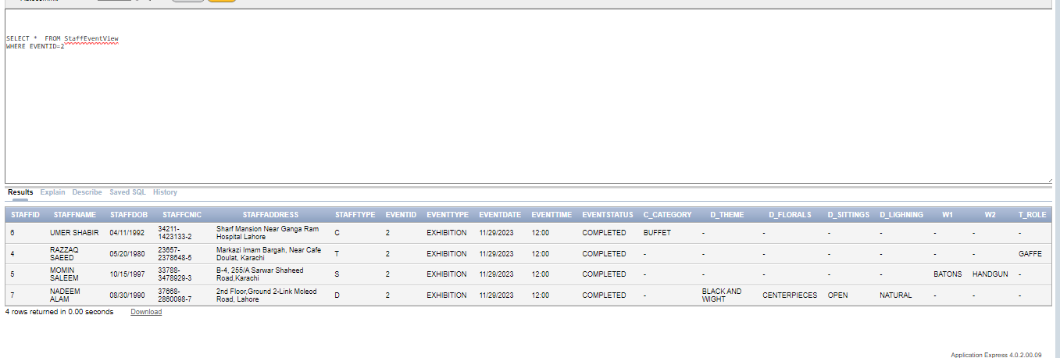

1. **CREATE A VIEW FOR RETRIEVING UPCOMING EVNETS WITH SOME DETAIL**

CREATE OR REPLACE VIEW UpcomingEventsView AS

SELECT

E.eventID AS EventID,

E.E_type AS EventType,

E.E_date AS EventDate,

E.E_time AS EventTime,

E.E_status AS EventStatus,

O.ORGID AS "ORGANIZER ID",

O.ORG_NAME AS "ORGANIZER NAME",

V.venueID AS VenueID,

V.V_NAME AS "VENUE NAME",

C.customerID AS CustomerID,

C.C_NAME AS "CUSTOMER NAME"

FROM

Event E

LEFT JOIN ORGANIZER O ON O.ORGID=E.ORGID

LEFT JOIN CUSTOMER C ON C.CUSTOMERID=E.CUSTOMERID

LEFT JOIN VENUE V ON V.VENUEID=E.EVENTID

WHERE

E_date > SYSDATE;

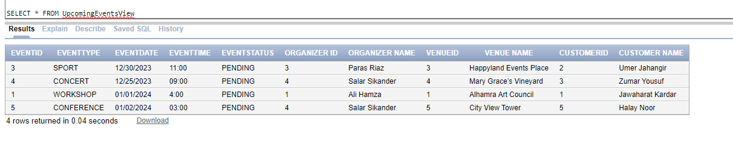

---------------------------------------------------------------------------------------

***Relational Data Model showing association***

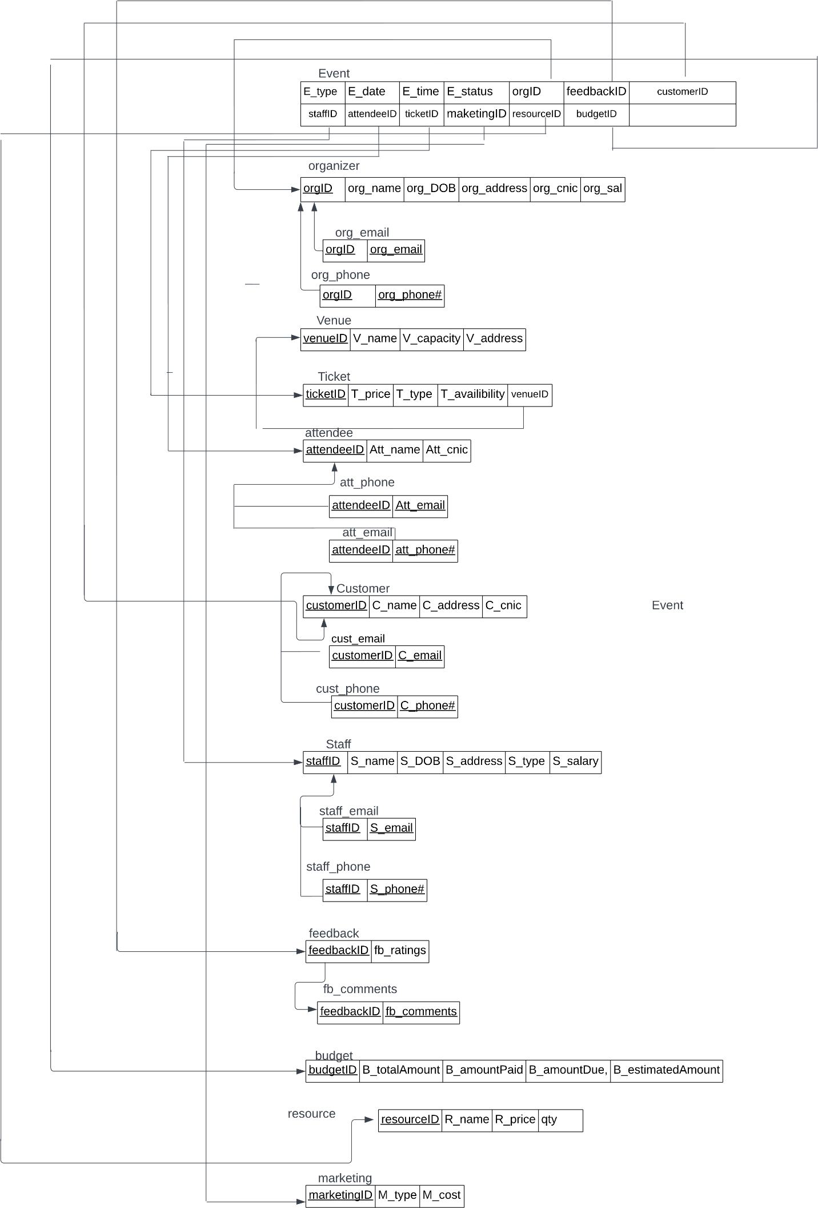

***Reports***

1. **2nd minimum salary of an organizer**

SELECT * FROM organizer org1

WHERE 1 = ( SELECT COUNT(DISTINCT org2.org_salary) FROM organizer org2

WHERE org2.org_salary < org1.org_salary);

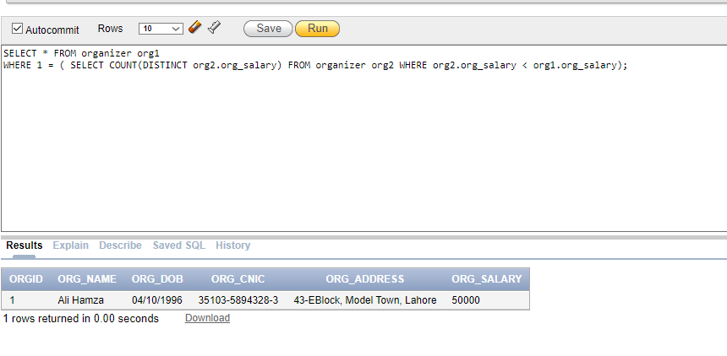

1. **Retrieve marketing approach used in event**

SELECT E.eventID, E.E_type,E.E_Date, E.E_time, E.E_status, M.M_type, M.M_cost,

CASE

WHEN M.M_type = 'D' THEN

'Social Media: ' || D.DM_socialMedia || ', Email: ' || D.DM_email || ', SEO: ‘|| D.DM_SEO || ', Strategy: ' || D.DM_strategy

WHEN M.M_type = 'T' THEN

'Material: ' || T.TM_material || ', Media Outlet: ' || T.TM_mediaOutlet || ', Print Production: ' || T.TM_printProduction

END AS MarketingDetail

FROM

Event E JOIN Marketing M ON E.marketingID = M.marketingID

LEFT JOIN

Traditional T ON M.M_type = 'T' AND M.marketingID = T.marketingID

LEFT JOIN

Digital D ON M.M_type = 'D' AND M.marketingID = D.marketingID;

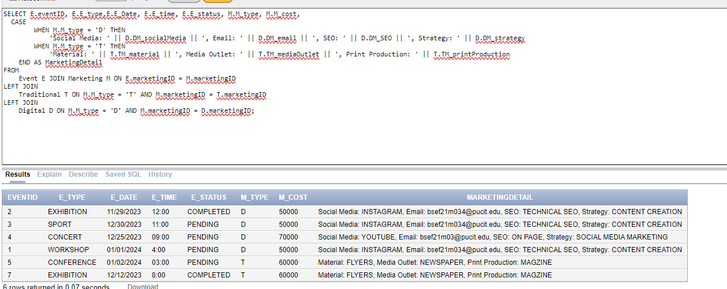

1. **Tickets used / tickets left for a venue**

SELECT e.eventID, e.E_type, v.V_name, v.V_capacity AS TotalTickets,

COUNT(t.ticketID) AS TicketsUsed,

v.V_capacity - COUNT(t.ticketID) AS TicketsLeft

FROM ticket t

JOIN venue v ON v.venueID = t.venueID

JOIN event e ON e.venueID = v.venueID

GROUP BY

e.eventID, e.E_type, v.V_name, v.V_capacity;

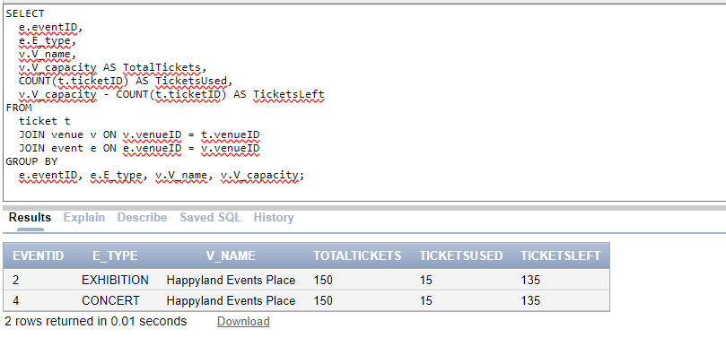

1. **Find in which event there are Maximum number of attendees**

SELECT e.eventID, e.E_type,

e.E_date, e.E_time, e.E_status, (SELECT MAX(attendee_count) FROM (SELECT eventID, COUNT(attendeeID) AS attendee_count FROM

Attendee GROUP BY eventID)) AS MaxAttendeeCount

FROM Event e

WHERE

(SELECT COUNT(attendeeID) FROM Attendee a WHERE a.eventID = e.eventID) =

(SELECT MAX(attendee_count) FROM (SELECT eventID, COUNT(attendeeID) AS attendee_count FROM Attendee GROUP BY eventID));

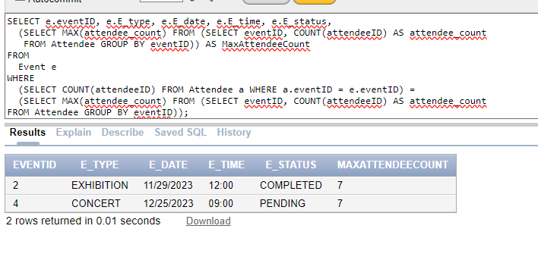

1. **Sort the events with respect to their feedback ratings in decreasing order**

SELECT e.eventID, e.E_type, nvl(AVG(f.fb_rating),0) AS Ratings

FROM

Event e

LEFT JOIN Feedback f ON e.feedbackID = f.feedbackID

GROUP BY

e.eventID, e.E_type

ORDER BY

Ratings DESC;

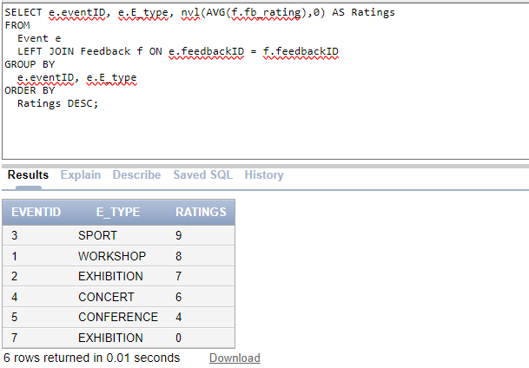

***Triggers, Procedures, Functions***

***TRIGGERS***

1. **TRIGGER BEFORE INSERTION ON EVENT TO VALIDATE THAT IF DATE AND TIME AND STATUS ARE VALID WITH EACH OTHER T**

CREATE OR REPLACE TRIGGER EventStatusTrigger

BEFORE INSERT OR UPDATE ON Event

FOR EACH ROW

BEGIN

IF ((:NEW.E_date >= SYSDATE) AND (TO_TIMESTAMP(:NEW.E_TIME,'HH12:MI') < CURRENT_TIMESTAMP)) AND (:NEW.E_STATUS = 'COMPLETED') THEN

RAISE_APPLICATION_ERROR(-20001, 'EVENT STATUS IS INVALID! Event can not be completed before the held date.');

ELSIF((:NEW.E_date <= SYSDATE) AND (TO_TIMESTAMP(:NEW.E_TIME,'HH12:MI') <= CURRENT_TIMESTAMP)) AND (:NEW.E_STATUS = 'PENDING')

THEN

RAISE_APPLICATION_ERROR(-20002, 'EVENT STATUS IS INVALID! Event can not be PENDING AFTER the held date.');

END IF;

END;

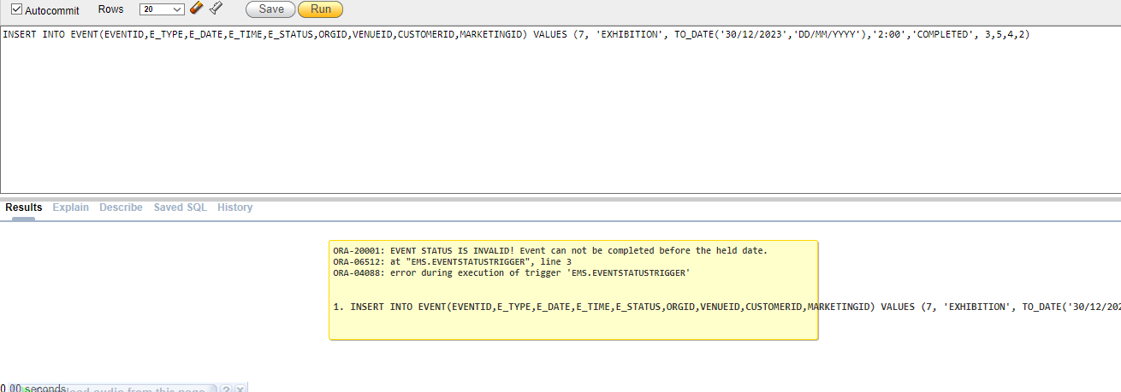

1. **Trigger before insertion and updation on RES for calculating and setting total amount and amount due.**

CREATE OR REPLACE TRIGGER UpdateBudgetTotalTrigger

BEFORE INSERT OR UPDATE ON Res

FOR EACH ROW

DECLARE

v_totalAmount NUMBER(10, 2);

M_SUM NUMBER(10, 2);

v_Due NUMBER(10, 2);

BEGIN

v_totalAmount := :NEW.R_qty * :NEW.R_price;

IF B_totalAmount IS NULL THEN

SELECT v_totalAmount + M.M_cost

INTO M_SUM

FROM Marketing M

WHERE M.marketingID = (SELECT marketingID FROM Event WHERE eventID = :NEW.eventID);

ELSE

M_SUM := B_totalAmount;

END IF;

UPDATE Budget

SET B_totalAmount = NVL(B_totalAmount, 0) + M_SUM

WHERE eventID = :NEW.eventID;

-- Calculate amount due

SELECT (B_TOTALAMOUNT - B_amountPaid) INTO v_Due

FROM Budget

WHERE eventID = :NEW.eventID;

UPDATE Budget

SET B_amountDue = v_Due

WHERE eventID = :NEW.eventID;

END;

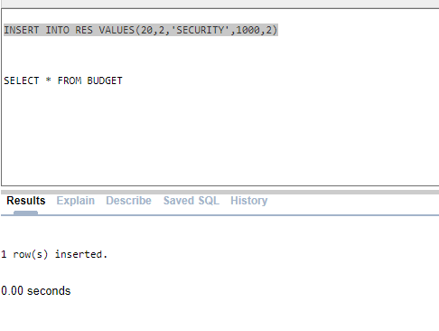

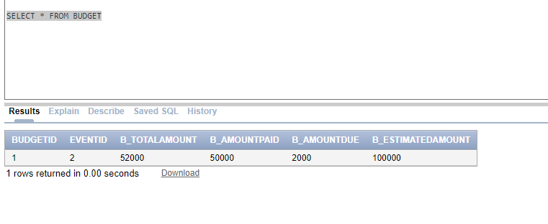

***Procedures:***

1. **Find staff and display details from its CNIC**

CREATE OR REPLACE PROCEDURE FIND_STAFF(input VARCHAR2)

IS

CURSOR CURS_STAFF IS SELECT * FROM ST WHERE S_CNIC = INPUT;

DETAIL ST%ROWTYPE;

v_StaffCount NUMBER := 0;

BEGIN

OPEN CURS_STAFF;

LOOP

FETCH CURS_STAFF INTO DETAIL;

EXIT WHEN CURS_STAFF%NOTFOUND;

END LOOP;

v_StaffCount := CURS_STAFF%ROWCOUNT;

IF v_StaffCount > 0 THEN

DBMS_OUTPUT.PUT_LINE('STAFF ID IS: ' || DETAIL.STAFFID);

DBMS_OUTPUT.PUT_LINE('EVENT ID IS: ' || DETAIL.EVENTID);

DBMS_OUTPUT.PUT_LINE('STAFF NAME IS: ' || DETAIL.S_NAME);

DBMS_OUTPUT.PUT_LINE('STAFF DOB IS: ' || DETAIL.S_DOB);

DBMS_OUTPUT.PUT_LINE('STAFF CNIC IS: ' || DETAIL.S_CNIC);

DBMS_OUTPUT.PUT_LINE('STAFF ADDRESS IS: ' || DETAIL.S_ADDRESS);

DBMS_OUTPUT.PUT_LINE('STAFF TYPE IS: ' || DETAIL.S_TYPE);

ELSE

DBMS_OUTPUT.PUT_LINE('NO STAFF FOUND FOR GIVEN CNIC');

END IF;

CLOSE CURS_STAFF;

END FIND_STAFF;

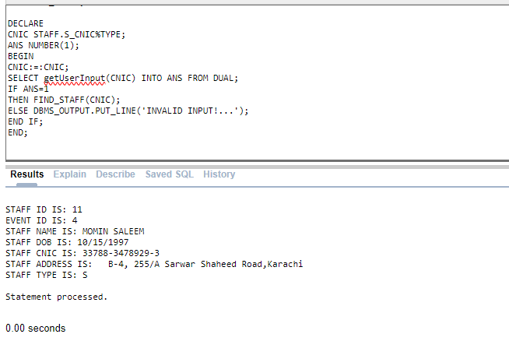

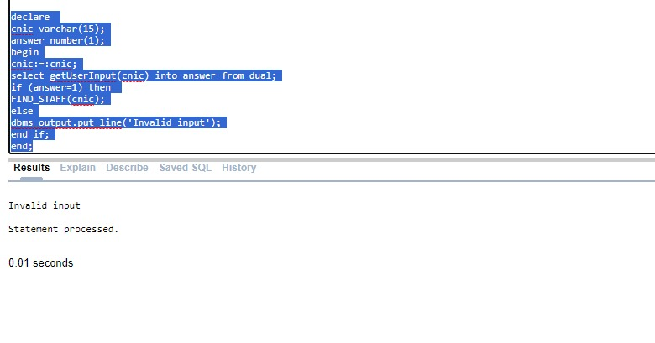

1. **Procedure for increase in organizer’s salary on basis of range**

CREATE OR REPLACE PROCEDURE sal_raise(sal IN out NUMBER)

AS

s NUMBER := 0;

BEGIN

IF sal between 20000 and 50000 THEN

s := sal * 0.05;

IF s > 15000 THEN

s := 15000;

END IF;

ELSIF sal between 50001 and 80000 THEN

s := sal * 0.10;

IF s > 15000 THEN

s := 15000;

END IF;

ELSIF sal between 80001 and 120000 then

s := sal * 0.15;

IF s > 15000 THEN

s := 15000;

END IF;

END IF;

sal:=sal+s;

EXCEPTION

WHEN NO_DATA_FOUND THEN

DBMS_OUTPUT.PUT_LINE('NO DATA FOUND');

END sal_raise;

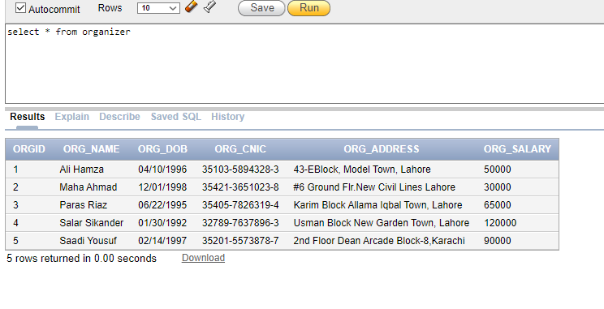

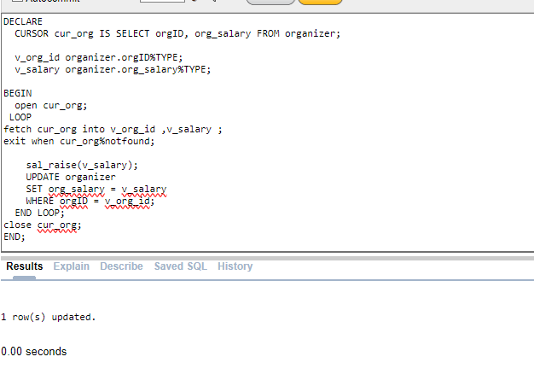

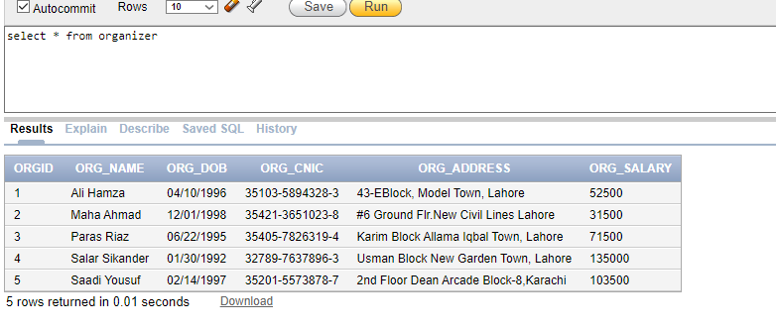

***Functions:***

1. **Validate CNIC of either customer,staff or organizer**

create or replace function getUserInput(cnic varchar2)

return number is

c char(1);

begin

if (length(cnic) != 15) then

return 0;

end if;

for i in 1..15 loop

c := substr(cnic, i, 1);

if (c >= lower('a') and c <= lower('z')) then

return 0;

elsif (i = 6 OR i = 14) then

if (c != '-') then

return 0;

end if;

end if;

end loop;

return 1;

end;

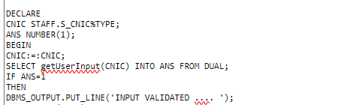

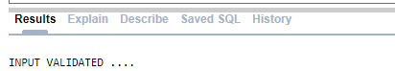

1. **CHECKS WHETHER A CERTAIN EVENT HAS REGISTERED ATTENDEES OR NOT**

CREATE OR REPLACE FUNCTION HasRegisteredAttendees(ID IN NUMBER)

RETURN BOOLEAN

AS

attendeeCount NUMBER;

BEGIN

SELECT COUNT(*) INTO attendeeCount FROM AttendeE WHERE EventID = ID;

return attendeeCount > 0;

END HasRegisteredAttendees;



